# Product Backlog

Note: List of User Stories before prioritisation and estimation.

Stories that contain colour coded criteria are probably going to be listed as Epics and broken down into User Stories per each criteria (e.g. user can send Messages, record Meetings, add Blog entries, add Uploads).

Assumption are marked **[Assumption].** Unclear areas are marked **{?}**

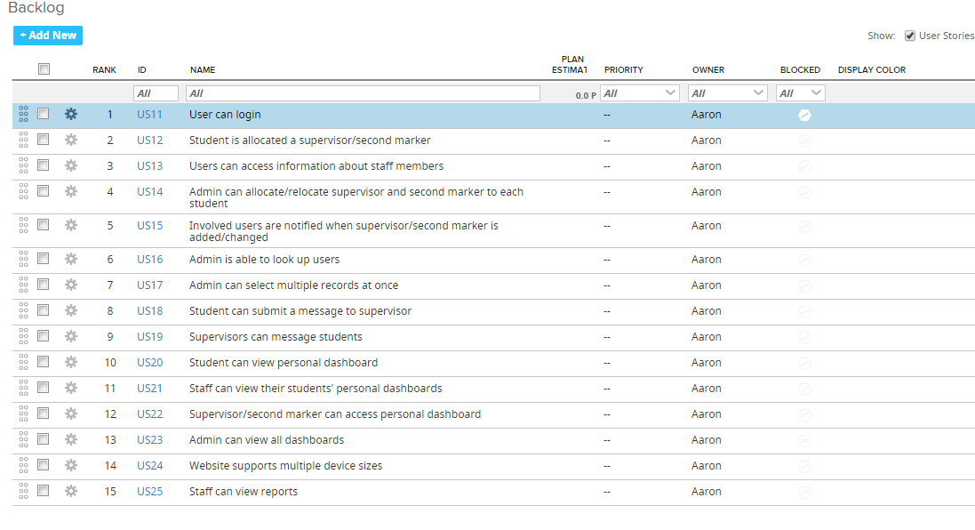

Figure User Stories with ID in RallyDev

1. As a user of the system I should be able to log in in order to access relevant functionality. As a non-authorised user I should not be able to access the system.

**[Assumption]:** *only students and staff of CIS would be allowed access. There are three levels of access and hence three types of user: student, staff, admin.*

1. As a student user I must have a supervisor and a second marker allocated for the purposes of being marked and communication.
2. As a student I would like to see information about my supervisor/second marker so that I can contact them regarding my work.

- directs to the Greenwich staff page (open in new tab - an improvement to opening a new site in the same tab).

1. As an admin user I can allocate and relocate a supervisor and a second marker for each student, so that marking can be completed.

* should not be able to delete once allocated
  + **[Assumption]:** *should not be able to leave a student without a supervisor and second marker for the project - a student should always have a supervisor/ second marker*
  + **[Assumption]:** *a student doesn't have any supervisor/second marker allocated when they first register on the course*
* check the supervisor and second marker are different
  + **[Assumption]:** *a student has a different supervisor and second marker allocated*
* email notifications are sent to student/old supervisor/old second marker/new supervisor/new second marker
  + **[Assumption]:** *lastly amended staff assignees also get an email, so they know they are not responsible for marking that student’s work if no longer listed as supervisor/second marker*
* display all available staff in a list
* search for/filter staff by first name, last name, staff ID, school
  + **{? Are lecturers assigned to a specific programme? }**
* (Nice to have:) demonstrate that a second year student not on the project course cannot access the project system functionality

1. As a student/staff user I would like to get an email notification when a supervisor/second marker is added or changed, so I know who to contact for communication related to the course.
2. As a member of staff I would like to look up a user by first name, last name or student ID/number so I can view their record.
3. As an admin I would like to select up to 10 people at once to allocate supervisor/second marker to, so that I don't need to repeat this individual student records multiple times.

* search for students by programme
* (Nice to have:) search by staff member first name, last name, staff ID - use case: select multiple student records and only change supervisor/second marker once, click a button to make the change

1. As a student I would like to be able to message my supervisors through the system so that it retains messaging history I can refer to later.

**[Assumption]:** *users cannot upload a file to a message for security purposes – to avoid spreading viruses*

Messages:

* view messages with dates and who sent them

**[Assumption]:** *users will not be able to edit comments or messages so that the messaging history remains accurate*

Meetings:

* arrange a meeting - request /cancel a requested one, staff can accept/reject -> pending -> record or dismiss
  + **[Assumption]:** *students cannot record held meeting so that they do not input fake information to maintain accuracy*

Uploads: {? is it within the scope of this coursework}

* upload documents for feedback and for marking
* comment on documents uploaded by member of staff

Blog:

* submit a blog entry - view date and time of submission
* view comments on blog entries

1. [Epic] As a supervisor I would like to be able to message all my students on a particular course through the system and retain messaging history.

Messages:

* reply to a message
* write a message
* should be able to view messages from past 7 days, 28 days and all

Meetings:

* record meetings held
* specify type of meeting, set as virtual/real
* upload a file for meeting recording

Blog:

* should be able to comment on blog entries

Uploads:

* upload revised work with feedback
* comment on uploads

1. As a student I would like to be able to view my dashboard page with a summary of interactions.

* message history (default: past 7 days), 28 days, all
* meetings summary (date, content, comments, URL)
* blog entries summary (date and time, content, comments)
* uploads (student, supervisor/second marker) - date and time, content, comments

1. As a supervisor/second marker I would like to be able to view a dashboard for each of my students.

[Design Question: through own dashboard or via a button?]

* search for a student (by name , programme, or id/number)
* filter students (by programme, name, id)
* view student’s dashboard

1. As a supervisor/second marker I would like to be able to view my personal dashboard

* meeting summary (date, content, comments, URL)
* blog entries summary (date and time, content, comments)
* uploads (student, supervisor/second marker) - date and time, content, comments
* message history (default: past 7 days), 28 days, all

1. As an admin I would like to be able to view dashboards of both staff and students

[Design Question: through own dashboard or via a button]

1. As a developer I would like the system to be able to support mobile/tablet/desktop.

* research responsive design
* mobile-first approach
* develop 3 consistent UIs - mobile, tablet, desktop
* keep it clean of distracting and repetitive content
* have a clean, easy to navigate, intuitive and simple to use interface
* document design principles

1. Reporting

* average number of messages per supervisor
* students without a supervisor
* students without a second marker
* students with no interactions for the last 7 days
* students with no interactions for the last 28 days